|  |  |
| --- | --- |
| **DOKUMENTASI EKSTERNAL**  External Documentation |  |
| **[~~TUGAS MANDIRI~~ / PROYEK ]**  **[*~~Assignment~~ / Project*]** |
| **MATAKULIAH < COMP6176> – HUMAN AND COMPUTER INTERACTION**  ***Subject*** |
| SEMESTER [~~GANJIL~~/GENAP/~~PENDEK~~] 2019/2020 ***[~~Odd~~/Even/~~Compact~~] Semester Year 2019/2020*** |

## Judul Proyek

*[Assignment / Project]**Title*

* **Rainbow Seven Siege Website**

## Abstrak [50 – 200 words]

*Abstract*

* **Rainbow Seven is a game developed by Ubipost, recently they released the 51st and 52nd operator for their game. With the new upcoming updates on the game, the company also wanted to update their website.**

## Pendahuluan

*Introduction*

* **This website displays the game information, operator, quarantine, maps, and user can pre-order the game before it released.**

## Dokumentasi

*Report / Documentation*

* **REPORT / PRINT SCREEN & DESCRIPTION**
  + **HomePage [Desktop View]**

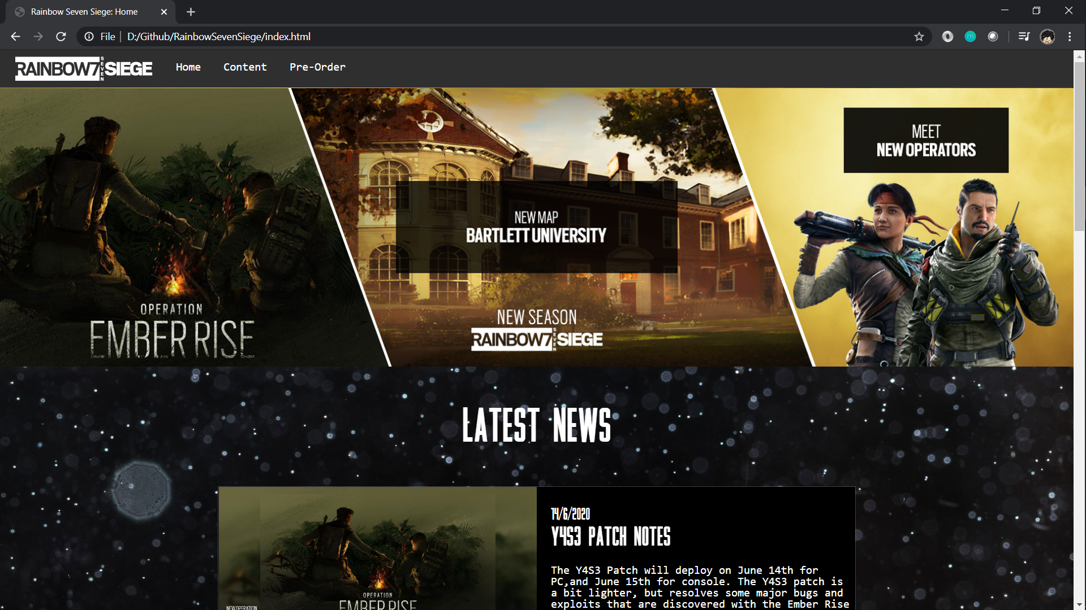

* + **Operators Page [Desktop View]**

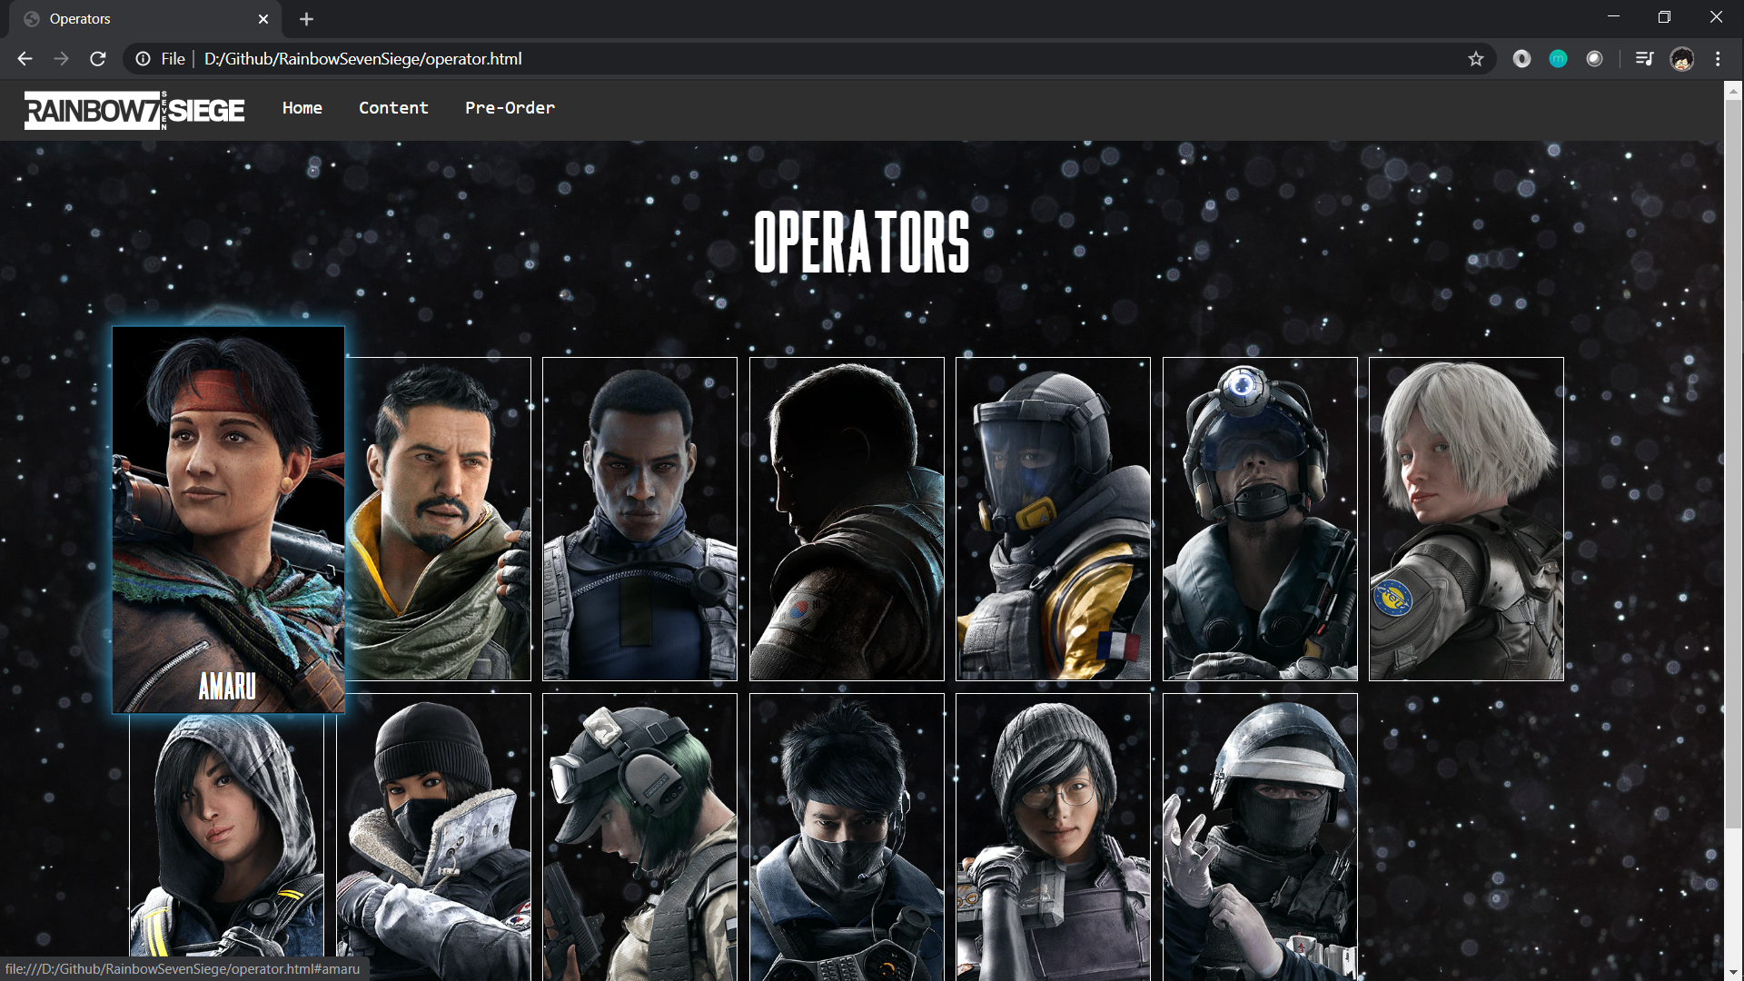

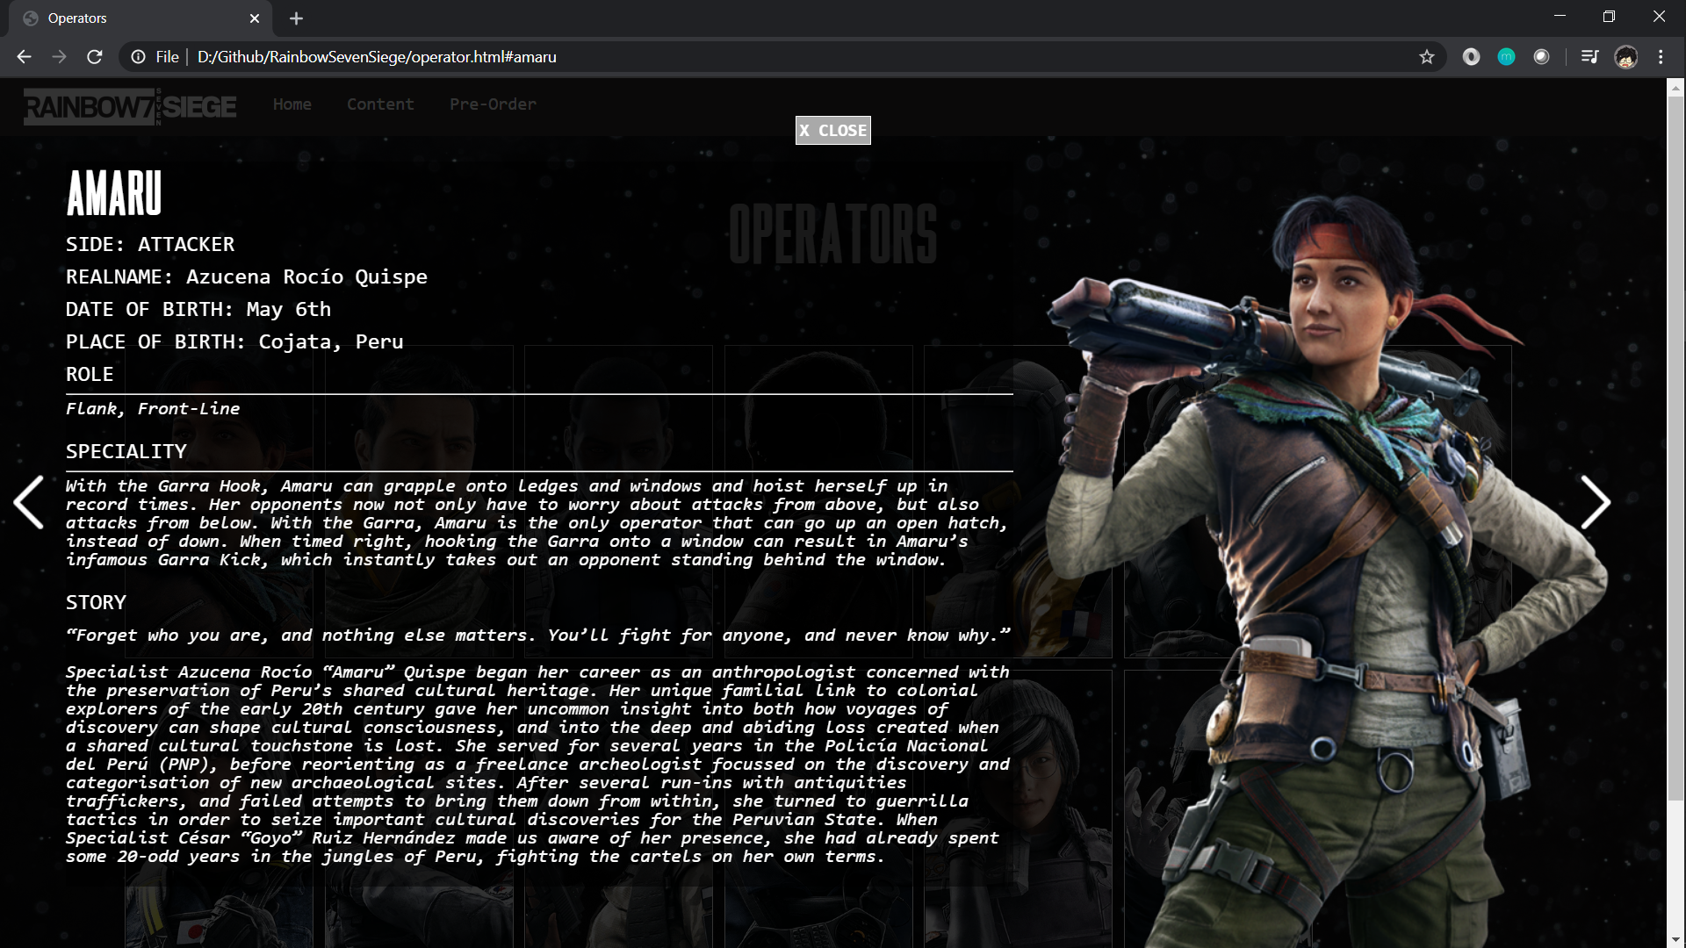

* + **Maps Page [Desktop View]**

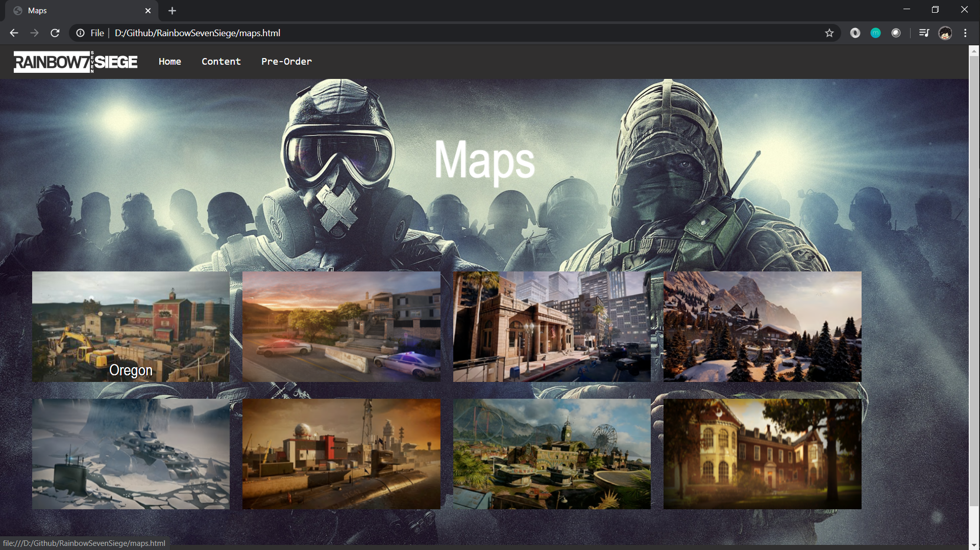

* + **Quarantine Page [Desktop View]**

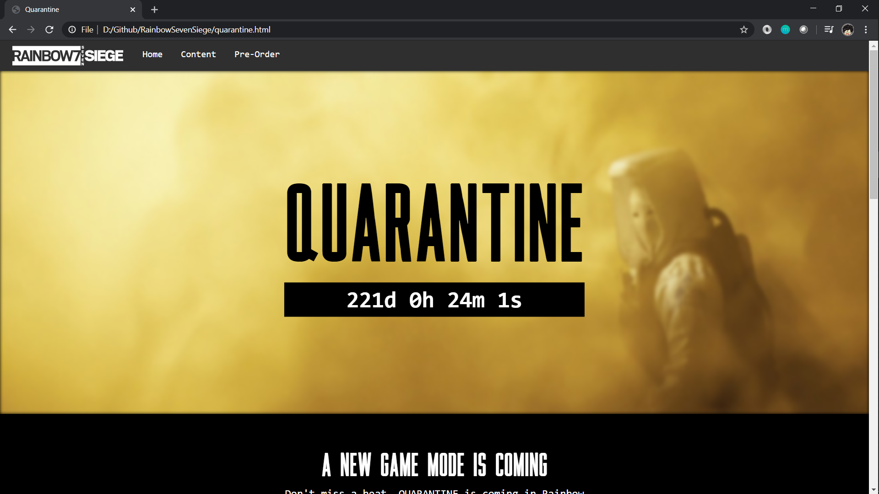

* + **Pre-Ordere Page [Desktop View]**

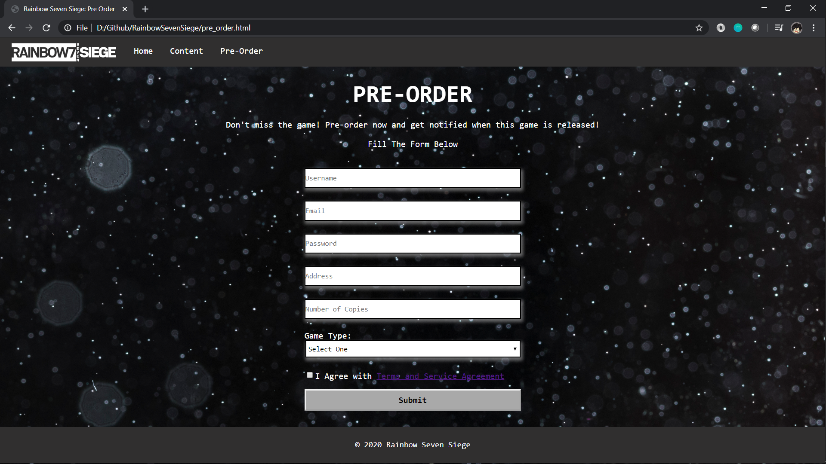

## Referensi

*References*

* **REFERENCES AND LINK**

1. **Reset CSS**

<https://meyerweb.com/eric/tools/css/reset/>

1. **Image Operator**<https://www.ubisoft.com/en-gb/game/rainbow-six/siege/game-info/operators>
2. **Font bebasneue**<https://www.dafont.com/search.php?q=bebasneue>
3. **Font Monaco**

<https://www.dafontfree.net/freefonts-monaco-f137518.htm>

1. **Font Scout (For Logo R7)**

<https://www.dafontfree.io/scout-font-family/>

1. **All images for Map and Operator**

<https://rainbowsix.fandom.com/wiki/Rainbow_Six_Wiki>

1. **Icon next**<https://www.flaticon.com/free-icon/next_130884>
2. **Background Night Star**<https://www.freepik.com/free-photo/defocused-night-sky-full-stars_4995771.htm#page=1&query=wallpaper%20star%20night&position=46>
3. **Wallpaper Maps**<https://all-free-download.com/wallpapers/download/mute_kapkan_tom_clancys_rainbow_six_siege_wallpaper_17276.html>
4. **Wallpaper Home Operator**<https://wall.alphacoders.com/big.php?i=685659>
5. **Rainbow Six Wallpaper**

<https://www.deviantart.com/naka47/art/Rainbow-Six-Siege-Article-5-Wallpaper-677050450>

1. **Rainbow Siege Font**

<https://www.dafont.com/rainbow.font?text=RAINBOWSIX+SIEGE&psize=l>

1. **Quarantine Background**

<https://www.ubisoft.com/en-gb/game/rainbow-six/siege/game-info/seasons/emberrise>

1. **Terms and Condition Script**

<https://www.termsofservicegenerator.net>

Disiapkan Oleh,

*Prepared by,*

* **2201823990 - Johan Eka Santosa**
* **2201762654 – Oei Jonathan Josi Gevin Wijaya**
* **2201751064 – Albert**
* **2201766034 – Willy Martin**